Elective in Software Engineering I

Final Project
Smart Greenhouse

Instructor:
Juan Antonio Castro Silva

Presented by:
Tomas Rojas Ramirez
20222208506
Nicolas Jimenez Medina
20222209445

Universidad Surcolombiana
Neiva, May 28, 2026
TABLE OF CONTENTS
1. INTRODUCTION 3
2. PROBLEM 4
3. OBJECTIVES 6
3.1 SPECIFIC OBJECTIVES 6
3.2 SPECIFIC OBJECTIVES 6
4. STATE OF THE ART 7
5. REQUIREMENTS 8
5.1 FUNCTIONAL REQUIREMENTS (FR) 9
5.2 NON-FUNCTIONAL REQUIREMENTS (NFR) 11
5.3 SYSTEM TECHNICAL REQUIREMENTS (TR) 12
6. USE CASES 12
6.1 ACTORS 12
6.2 LIST OF USE CASES (UC) 13
6.3 USE CASE DIAGRAM 13
7. USER STORIES 14
8. DATA DICTIONARY 19
8.1 COLLECTION: IMAGES (MONGODB) 19
8.2 DATA STRUCTURES EXPOSED BY THE API 23
8.2.1 ENDPOINT POST /ANALYZE 23
8.2.2 ENDPOINT GET/HISTORY 24
8.3 CORRESPONDENCE WITH FRONTEND STRUCTURES 26
9. CLASS DIAGRAM 26
9.1 DOMAIN AND DATA CLASSES (BACKEND) 27
9.2. SERVICE CLASSES (BACKEND) 27
9.3 SUMMARY OF THE BACKEND CLASS DIAGRAM 29
9.4 MAIN COMPONENTS IN THE FRONTEND 30
10. USER INTERFACE DESIGN 30
10.1 IMAGE SELECTION SCREEN 31
10.2 RESULTS SCREEN 32
10.3 HISTORY SCREEN 34
10.4 RESPONSIVENESS AND VISUAL CONSISTENCY CONSIDERATIONS 35
11. WEB SERVICE CATALOG AND API DOCUMENTATION 36
11.1 SERVICE: POST /ANALYZE 36
11.2 SERVICE: GET /HISTORY 39
11.3 SERVICE: GET /UPLOADS/<FILENAME> 40
11.4 SERVICE: GET /ANNOTATED/<FILENAME> 41
11.5 API FLOW SUMMARY 41
12. TESTING 42
13. GRAPHICAL MODEL OF THE PROPOSED SYSTEM 51
14. RESULTS AND CONCLUSION 52

INTRODUCTION
The Smart Greenhouse system is a web-based environmental management application designed for agricultural greenhouses. It allows users to register and monitor cultivation zones, associate plants with each zone, capture environmental sensor readings (temperature, humidity, light), and configure alert thresholds per metric.
The platform is aimed at technology-oriented farmers, agricultural researchers, and students who need to systematically track the environmental conditions of their crops without relying on spreadsheets.
The system is composed of the following components:
- REST Backend built with Java 17 + Spring Boot 3.5, following a hexagonal architecture
- Single Page Application (SPA) Frontend built with React 19 + TypeScript + Vite
- Relational database using PostgreSQL
- Authentication via OAuth2 with Google (Gmail accounts)
- Taiga.io integration for user story tracking via REST API
- CI/CD pipeline using GitHub Actions + Render + Vercel
Field | Value
Project name | Smart Greenhouse
Course | Elective 1 — Software Engineering
Modality | Pair work
Repository | https://github.com/tomas-rojasr/mi-invernadero
Frontend (production) | https://mi-invernadero-one.vercel.app
Backend (production) | https://mi-invernadero-back.onrender.com
Project management | https://tree.taiga.io/project/tomas-rojasr-invernadero-inteligente
Date | may 2026

PROBLEM
Small and medium-sized agricultural producers face the challenge of monitoring the environmental conditions of their crops without access to affordable and accessible tools. The following problems have been identified:
- Scattered manual records: Temperature, humidity, and light data are written down on paper or tracked in Excel spreadsheets, with no structure or queryable history.
- No deviation alerts: There is no way to know when a metric exceeds the optimal range for a given crop.
- Management of multiple zones: A greenhouse may contain several zones with different environmental conditions, yet no simple tool exists to centralize this information.
- Crop traceability: It is difficult to keep track of what was planted, when, how much, and what the yield was.
- Cross-platform access: Producers need to consult their data from any device with a web browser.
The proposed system addresses these problems through a centralized REST API, an intuitive web interface, and cloud-based data persistence.

OBJECTIVES

3.1 SPECIFIC OBJECTIVES
To develop a full-stack web application that enables the management of cultivation zones, the recording of environmental sensor readings, crop control, and the definition of alert thresholds, with secure authentication and continuous cloud deployment.

3.2 SPECIFIC OBJECTIVES
- Design and implement a relational data model with the entities Zone, Crop, Environmental Reading, and Environmental Threshold in PostgreSQL.
- Build a REST API with Spring Boot 3.5 following hexagonal architecture (ports and adapters), documented with OpenAPI/Swagger.
- Develop a Single Page Application (SPA) in React 19 + TypeScript that consumes the API and presents information in an intuitive way.
- Implement OAuth2 authentication with Google through Spring Security, with cross-domain support between the frontend (Vercel) and the backend (Render).
- Integrate the Taiga.io platform via its REST API to display the status of user stories directly within the application.
- Configure a CI/CD pipeline with GitHub Actions that runs automated tests (JUnit, Python) and deploys automatically upon approval.
- Implement internationalization (i18n) in Spanish and English on both the frontend and backend.
- Ensure minimum test coverage with unit tests (JUnit + Mockito), integration tests (MockMvc), REST API tests (Python + requests), and end-to-end tests (Selenium + Python).

STATE OF THE ART
The management of environmental conditions in agricultural greenhouses has traditionally relied on manual methods such as paper records, basic spreadsheets, or isolated sensor systems that lack centralized data collection and structured historical tracking. These approaches, while simple to implement, present significant limitations in terms of scalability, traceability, and real-time monitoring. The need for more systematic and accessible solutions has driven the development of web-based agricultural management platforms that combine sensor data collection, cloud persistence, and intuitive user interfaces.
Among the existing alternatives, systems such as Arduino combined with Google Sheets represent a common low-cost approach in small-scale agricultural contexts. However, this combination lacks a proper REST API, does not provide a structured web interface, and offers no queryable historical records beyond manual spreadsheet management. Commercial platforms such as Agrimonitor.io offer more complete monitoring solutions but at a high operational cost and without open-source access, which limits their adoption in academic and small-producer environments. Open-source alternatives like FarmHack exist but require advanced technical configuration and do not provide an integrated frontend, making them inaccessible to non-technical users. OpenFarm, on the other hand, focuses exclusively on a community crop catalog and does not support the recording of environmental data from the user's own greenhouse.
Given these limitations, the Smart Greenhouse system was designed as a full-stack web solution that addresses the identified gaps through a modern and well-documented technology stack. For the backend, Java 17 LTS and Spring Boot 3.5 were selected due to their mature ecosystem, strong enterprise support, and native integration with Spring Security for OAuth2 authentication. The architecture follows the hexagonal pattern — also known as ports and adapters — which separates business logic from infrastructure details such as database access and HTTP communication, enabling the core domain to be tested independently without requiring a running database or external services. Persistence is managed through Spring Data JPA with Hibernate as the ORM layer, using PostgreSQL as the relational database with automatic schema migrations via ddl-auto: update. API documentation is generated automatically from code annotations using SpringDoc OpenAPI, which produces a fully interactive Swagger UI available at /swagger-ui.html.
For the frontend, React 19 combined with TypeScript was chosen due to its dominant position in the UI ecosystem and the benefits of static typing for preventing runtime errors during development. The build process is handled by Vite 8, which provides significantly faster development and production build times compared to traditional bundlers. HTTP communication with the backend is managed through Axios, which natively supports session cookie handling via the withCredentials flag — a critical requirement for maintaining OAuth2 sessions across different domains. Internationalization is implemented using i18next, the standard library for React applications, while client-side routing with protected routes is managed by React Router 7. The deployment infrastructure relies on GitHub Actions for CI/CD automation, Render as the PaaS provider for the Java backend and managed PostgreSQL instance, and Vercel as the CDN and static hosting platform optimized for React applications.

REQUIREMENTS
The requirements of the Smart Greenhouse system were defined based on the problem analysis, the proposed architecture, and the functional objectives of the project. They are organized into three categories: functional requirements, which describe the specific behaviors the system must exhibit; non-functional requirements, which define quality attributes such as security, performance, and maintainability; and technical requirements, which establish the technology stack and tools used throughout the development. This structured classification ensures that both the expected behavior of the application and the constraints necessary for its correct operation are clearly documented.

5.1 FUNCTIONAL REQUIREMENTS (FR)
The functional requirements define the specific capabilities and behaviors that the system must provide to its users. Each requirement was derived from the identified user needs and directly maps to one or more use cases and user stories defined in subsequent sections.
ID | Name | Description
FR-01 | OAuth2 Authentication | The system allows users to sign in with a Google account. Without an active session, all API endpoints return HTTP 401.
FR-02 | Zone Management | The user can create, list, and delete greenhouse zones. Each zone includes a name, description, location, type (GREENHOUSE / OPEN_FIELD / HYDROPONIC / POTS), and area in m².
FR-03 | Crop Management | For each zone, the user can register, edit, and delete crops. Fields include name, variety, notes, planting date, estimated harvest date, area, quantity planted, expected yield, and status (ACTIVE / IN_PREPARATION / HARVESTED / LOST).
FR-04 | Reading Registration | The user can register environmental readings per zone. Metric types: TEMPERATURE_C, RELATIVE_HUMIDITY_PCT, LIGHT_LUX, SOIL_HUMIDITY_PCT. Each reading includes a source (MANUAL / AUTOMATIC_SENSOR) and optional notes.
FR-05 | Environmental Thresholds | The user can define and delete minimum/maximum thresholds per metric type and zone.
FR-06 | Reading History | The system returns the last N readings for a zone (default 50), ordered from most recent to oldest.
FR-07 | Taiga Integration | The system displays the complete list of user stories from the Taiga project, including reference, title, assignee, and status.
FR-08 | ER Diagram | The application includes a page displaying the entity-relationship diagram of the database.
FR-09 | Internationalization | The entire web interface is available in Spanish and English. The user toggles the language with a persistent button.
FR-10 | Demo Data | On startup with an empty database, the system automatically loads 3 zones, 5 crops, 10 readings, and 6 thresholds as sample data.
FR-11 | User Profile | The authenticated user can view their email address and sign out.
FR-12 | Cascade Deletion | When a zone is deleted, the system automatically removes all associated crops, readings, and thresholds.

5.2 NON-FUNCTIONAL REQUIREMENTS (NFR)
Non-functional requirements define the quality attributes and operational constraints that the system must satisfy independently of specific functional behaviors. These requirements directly influence architectural decisions, technology choices, and deployment strategies.
ID | Name | Description
NFR-01 | Availability | The system is deployed in the cloud (Render + Vercel) with a target uptime of 99% during academic hours.
NFR-02 | Security | All requests to protected resources require an active OAuth2 session. Session cookies use HttpOnly, Secure, and SameSite=None flags.
NFR-03 | Performance | The frontend loads in under 3 seconds on a 4G connection. The API responds in under 500 ms for simple CRUD operations.
NFR-04 | Maintainability | The hexagonal architecture ensures that the business layer can be tested without infrastructure dependencies (database, HTTP).
NFR-05 | Scalability | The use of UUIDs as identifiers and PostgreSQL as the database allows horizontal scaling of the backend.
NFR-06 | Internationalization | The system supports ES and EN without modifying source code; all texts are externalized in JSON files.
NFR-07 | Documentation | All endpoints are automatically documented in Swagger UI (/swagger-ui.html). Every public class and method includes Javadoc.
NFR-08 | Traceability | The CI/CD pipeline ensures that only code passing all tests reaches production.

5.3 SYSTEM TECHNICAL REQUIREMENTS (TR)
The technical requirements establish the specific technologies, frameworks, and tools that compose the system's implementation stack. These were selected based on ecosystem maturity, community support, and compatibility with the project's functional and non-functional requirements.
ID | Requirement | Value
TR-01 | Backend language | Java 17 LTS
TR-02 | Backend framework | Spring Boot 3.5
TR-03 | Database | PostgreSQL 15+
TR-04 | Frontend language | TypeScript 5+
TR-05 | Frontend framework | React 19 + Vite 8
TR-06 | Authentication | OAuth2 Authorization Code Flow (Google)
TR-07 | CI/CD | GitHub Actions
TR-08 | Backend deployment | Render (PaaS, free tier)
TR-09 | Frontend deployment | Vercel (static CDN)
TR-10 | Backend testing | JUnit 5 + Mockito + MockMvc
TR-11 | Frontend testing | Selenium 4 + Python 3.11
TR-12 | API testing | pytest + requests
TR-13 | API documentation | SpringDoc OpenAPI 3

USE CASES
The use case model describes the interactions between the actors of the system and the functional behaviors it must support. Each use case represents a specific goal that a user or external system can accomplish through the Smart Greenhouse platform. The identification of actors and use cases was derived directly from the functional requirements defined in the previous section, ensuring complete traceability between user needs and system capabilities.

6.1 ACTORS
The following actors were identified for the Smart Greenhouse system:
Actor | Description
Authenticated User | A person with a Google account who has successfully signed in. Can perform all CRUD operations available in the system.
Administrator | Same as the authenticated user in the academic context; no differentiated roles are defined at this stage.
IoT Sensor | An external actor that can register environmental readings via the API using the AUTOMATIC_SENSOR source, intended for future integration.
Taiga System | External project management platform; the backend queries it via REST using a bearer token.

6.2 LIST OF USE CASES (UC)
The following table presents the complete list of use cases identified for the system, along with the primary actor responsible for triggering each one and a brief description of its purpose.
ID | Name | Actor | Description
UC-01 | Sign In | User | Authenticate using Google OAuth2
UC-02 | Sign Out | User | Invalidate the active session
UC-03 | Create Zone | User | Register a new greenhouse zone
UC-04 | List Zones | User | View all registered zones
UC-05 | Delete Zone | User | Delete a zone and all its associated data
UC-06 | Register Crop | User | Add a crop to a zone
UC-07 | Edit Crop | User | Update the data of an existing crop
UC-08 | Delete Crop | User | Remove a crop from a zone
UC-09 | Register Reading | User / Sensor | Save an environmental measurement for a zone
UC-10 | View Readings | User | Consult the reading history for a zone
UC-11 | Delete Reading | User | Remove a specific reading
UC-12 | Define Threshold | User | Set a min/max range for a metric in a zone
UC-13 | Delete Threshold | User | Remove a defined threshold
UC-14 | View Taiga Stories | User | Consult the project's user stories from Taiga
UC-15 | View ER Diagram | User | Visualize the database entity-relationship model
UC-16 | Change Language | User | Toggle between Spanish and English

6.3 USE CASE DIAGRAM
The use case diagram presents a visual representation of the relationships between the actors and the use cases of the system. The primary actor, Authenticated User, interacts directly with all functional use cases from UC-03 to UC-16. UC-01 involves Google as an external actor in the OAuth2 authentication flow, while the IoT Sensor actor participates exclusively in UC-09 as an alternative source for registering environmental readings. The Taiga System acts as an external dependency consulted by the backend when the user accesses UC-14.
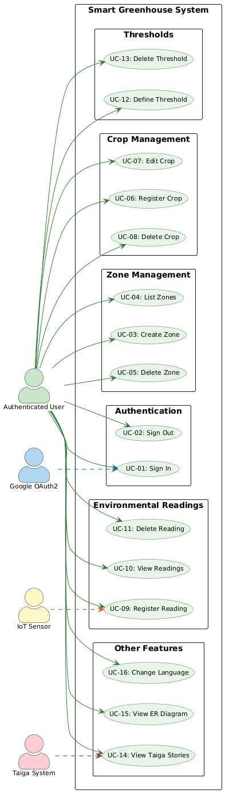

USER STORIES
The user stories were defined following the standard format "As a [role], I want [goal], so that [benefit]" and organized into epics that group related functionalities. Each story was registered in the Taiga project management platform at https://tree.taiga.io/project/tomas-rojasr-invernadero-inteligente/backlog and assigned to one of the two team members. The acceptance criteria described for each story define the minimum conditions that must be met for the story to be considered complete.
Epic 1 — Zone Management
# | User Story | Assigned | Acceptance Criteria
1 | As a farmer, I want to register a zone with name, description, type, and area, to organize my greenhouse by sections. | Tomas | Form validates that name is not empty. Zone type and area in m² can be specified. Zone appears immediately in the list after creation.
2 | As a farmer, I want to see the list of all active zones, to have a general overview of my greenhouse. | Nicolás | All registered zones are displayed in a table. Each row shows name, type, area, and creation date.
3 | As a farmer, I want to delete a zone, to keep the space catalog up to date. | Tomas | Zone is removed from the list immediately. All associated crops, readings, and thresholds are deleted automatically.
4 | As a farmer, I want the system to ask for confirmation before deleting a zone, to avoid accidental deletions. | Nicolás | A confirmation dialog appears before executing the deletion. Canceling the dialog leaves the zone intact.

Epic 2 — Crop Management
# | User Story | Assigned | Acceptance Criteria
5 | As a farmer, I want to register a crop with name, variety, planting date, and zone, to keep track of what has been planted. | Tomas | All required fields are validated. The crop is linked to a specific zone. It appears immediately in the crop list.
6 | As a farmer, I want to edit the data of an existing crop, to correct or update information. | Nicolás | Clicking Edit preloads the form with current data. Changes are reflected immediately in the table after saving.
7 | As a farmer, I want to register the expected yield and planted area, to plan the harvest. | Tomas | Fields for expected yield (kg) and area (m²) are available in the crop form. Values are stored and displayed correctly.
8 | As a farmer, I want to see the status of a crop (Active, In Preparation, Harvested, Lost), to know the progress of each planting. | Nicolás | Status is displayed visually in the crop table. It can be updated when editing the crop.
9 | As a farmer, I want to filter crops by zone, to see only the ones I am interested in. | Nicolás | A zone selector filters the crop list. Only crops belonging to the selected zone are displayed.
Epic 3 — Environmental Readings
# | User Story | Assigned | Acceptance Criteria
10 | As a farmer, I want to register an environmental reading (temperature, humidity, light, soil humidity) for a zone, to monitor the surrounding conditions. | Tomas | Metric type, value, source, and zone can be selected. Reading appears in the zone's history after registration.
11 | As a farmer, I want to see the reading history by zone, to analyze environmental trends. | Nicolás | Readings are listed ordered from most recent to oldest. Up to 50 readings are displayed by default.
12 | As a farmer, I want to indicate whether a reading was manual or from an automatic sensor, to distinguish the origin of the data. | Tomas | Source field (MANUAL / AUTOMATIC_SENSOR) is available in the reading form. Value is stored and visible in the history.
13 | As a farmer, I want to add notes to a reading, to record specific observations. | Nicolás | An optional notes field is available when registering a reading. Notes are displayed in the reading history.
14 | As a farmer, I want to delete an erroneous reading, to maintain data integrity. | Tomas | A delete option is available for each reading. The reading disappears from the list immediately after deletion.
Epic 4 — Environmental Thresholds
# | User Story | Assigned | Acceptance Criteria
15 | As a farmer, I want to define a minimum and maximum threshold per metric type for each zone, to establish optimal operating ranges. | Tomas | Min and max values can be set per metric and zone. If a threshold already exists for that metric, it is updated (upsert).
16 | As a farmer, I want to see the thresholds configured per zone, to verify the control parameters. | Nicolás | All thresholds for a selected zone are displayed in a table with metric type, min, and max values.
17 | As a farmer, I want to update an already defined threshold, to adjust the ranges according to the season. | Tomas | Editing a threshold preloads the current values. Changes are saved and reflected immediately.
Epic 5 — Authentication and Profile
# | User Story | Assigned | Acceptance Criteria
18 | As a user, I want to sign in with my Google account, to access the system securely. | Tomas | The "Sign in with Google" button redirects to the OAuth2 flow. After authentication, the user reaches the main panel. Without a session, the API returns 401.
19 | As a user, I want to see my profile with my email and session status, to know which account I am connected with. | Nicolás | The profile page displays the authenticated user's email. Session status is shown correctly.
20 | As a user, I want to sign out, to protect my account on shared devices. | Nicolás | Clicking sign out invalidates the session. The user is redirected to the login page. Protected routes return 401 after signing out.

Epic 6 — Interface and Usability
# | User Story | Assigned | Acceptance Criteria
21 | As a user, I want to change the interface language between Spanish and English, to use the system in my preferred language. | Nicolás | The ES/EN toggle button in the header switches the language. The preference persists after reloading the page.
22 | As a user, I want to see an interactive entity-relationship diagram of the database, to understand the structure of the system. | Nicolás | The diagram page displays all 4 entities with their fields, types, primary keys, and foreign keys. Relationships are visually indicated.
23 | As a developer, I want to query Taiga user stories from within the application, to integrate project management with the system. | Tomas | The Taiga page displays a table with reference, title, assignee, and status for each story. Data is fetched in real time from the Taiga API.
Epic 7 — Quality and Deployment
# | User Story | Assigned | Acceptance Criteria
24 | As a team, we want the system to be deployed automatically when pushing to main, to reduce the time to deliver changes. | Tomas | A GitHub Actions pipeline runs backend tests (JUnit) and frontend build (tsc + Vite) on every push. If all checks pass, the backend is redeployed on Render automatically.

DATA DICTIONARY
The Smart Greenhouse system uses a PostgreSQL relational database organized into four main tables: zonas, cultivos, lecturas_ambientales, and umbrales_ambientales. All tables use UUIDs as primary keys to ensure uniqueness across distributed environments and to facilitate future horizontal scaling of the backend. Relationships between tables are enforced through foreign key constraints, and cascade deletion is configured at the application level to ensure referential integrity when a zone is removed.
The complete data dictionary — including column names, SQL data types, nullability constraints, default values, and field descriptions for all four tables — is documented in the following spreadsheet:
Data Dictionary (Google Sheets):
https://docs.google.com/spreadsheets/d/1otG0fFlJtnQY-eBAmZ4Vtx6XPEVqmtnHKJaSc5Cl6cY/edit?usp=sharing
This file also includes the domain enumerations used throughout the system: MetricType, ZoneType, CropStatus, and ReadingSource, along with the JSON response structures exposed by the REST API for each entity. The complete API documentation, including all request and response structures with live examples, is additionally available through the Swagger UI at:
Swagger UI:
https://invernadero-back.onrender.com/swagger-ui/index.html

CLASS DIAGRAM
The class diagram of the Smart Greenhouse system describes the logical structure of the backend, representing the domain entities, the service classes responsible for business logic, and the repository interfaces that handle data persistence. The architecture follows the hexagonal pattern — also known as ports and adapters — which enforces a clear separation between the core business logic and the infrastructure details such as database access and HTTP communication. This separation is reflected in the class diagram through the distinction between domain classes, application services, port interfaces, and JPA adapters.

9.1 DOMAIN AND DATA CLASSES (BACKEND)
At the core of the system are the domain classes that represent the data managed and stored in the PostgreSQL database. These classes are directly derived from the relational model documented in the data dictionary.
The Zona class represents a physical or logical section of the greenhouse. It contains attributes such as id (UUID), nombre, descripcion, ubicacion, tipo (ZoneType enum), areaM2, and creadoEn. This class maintains a one-to-many composition relationship with the Cultivo, LecturaAmbiental, and UmbralAmbiental classes, since each zone can contain multiple crops, readings, and thresholds. When a zone is deleted, all associated records are removed through cascade deletion managed at the application service level.
The Cultivo class models the information of each crop registered within a zone. Its attributes include id, zonaId, nombre, variedad, notas, plantadoEn, fechaCosechaEstimada, areaM2, cantidadSembrada, rendimientoEsperadoKg, estado (CropStatus enum), and creadoEn. This class is associated with a single Zona instance through a foreign key relationship.
The LecturaAmbiental class represents a single environmental measurement taken in a zone. Its attributes include id, zonaId, tipo (MetricType enum), valor, fuente (ReadingSource enum), notas, and registradoEn. Each reading belongs to exactly one zone and is ordered by timestamp for history retrieval purposes.The UmbralAmbiental class defines the acceptable operating range for a specific metric within a zone. Its attributes include id, zonaId, tipo, valorMin, valorMax, and actualizadoEn. The system supports one threshold per metric type per zone, and the creation or update operation is implemented as an upsert at the service level.

9.2. SERVICE CLASSES (BACKEND)
The Spring Boot backend is organized into application service classes that encapsulate the business logic for each domain entity. These services operate exclusively on domain objects and port interfaces, without direct knowledge of JPA or HTTP details.
The ZonaApplicationService class is responsible for all zone-related operations. Its main methods include crear(CrearZonaRequest), listarTodas(), buscarPorId(UUID), and eliminar(UUID). The elimination method orchestrates the cascade deletion of all associated lecturas, cultivos, and umbrales before removing the zone itself, ensuring referential integrity without relying on database-level cascade constraints.
The CultivoApplicationService class manages crop lifecycle operations within a zone. Its methods include registrar(UUID zonaId, CrearCultivoRequest), actualizar(UUID zonaId, UUID cultivoId, ActualizarCultivoRequest), listarPorZona(UUID zonaId), and eliminar(UUID zonaId, UUID cultivoId). All operations first verify the existence of the parent zone before executing.
The LecturaApplicationService class handles the registration and retrieval of environmental readings. Its key methods are registrar(UUID zonaId, RegistrarLecturaRequest) and listarUltimas(UUID zonaId, int limite). The listing method returns readings ordered from most recent to oldest, with a configurable limit defaulting to 50.
The UmbralApplicationService class manages threshold definition and deletion. Its methods include definirOActualizar(UUID zonaId, DefinirUmbralRequest) and eliminar(UUID zonaId, UUID umbralId). The upsert logic checks for an existing threshold of the same metric type in the zone before deciding whether to create or update the record.
The TaigaApplicationService class acts as a proxy toward the external Taiga.io REST API. It authenticates using a configured bearer token stored as a server-side environment variable (TAIGA_TOKEN in Render), ensuring the credential is never exposed to the browser. For long-term stability, the project uses a Taiga Application Token (created under Settings → Apps in Taiga), which does not expire, unlike regular session tokens that expire after 24 hours. Its methods are listarHistorias() and buscarHistoriaPorId(Long id).

9.3 PORT INTERFACES AND ADAPTERS
Each domain entity is associated with a port interface that defines the persistence contract, and a corresponding JPA adapter that implements it. This structure is the core of the hexagonal architecture applied in the project.
The ZonaPort interface defines methods such as guardar(Zona), buscarPorId(UUID), listarTodas(), and eliminar(UUID). Its implementation, ZonaJpaAdapter, delegates these operations to the ZonaJpaRepository, which extends Spring Data's JpaRepository. The same pattern is applied for CultivoPort, LecturaPort, and UmbralPort, each with their corresponding JPA adapters and repositories.
This separation ensures that the application service classes depend exclusively on port interfaces rather than concrete implementations, enabling the business logic to be tested in isolation using mock adapters without requiring a running database instance.

9.4 MAIN COMPONENTS IN THE FRONTEND
Although the frontend is implemented using React functional components with hooks, the documentation represents the main components as logical units with defined state and properties. The root component App manages global authentication state and route protection through React Router 7. Protected routes verify the session status via the /api/v1/auth/status endpoint before rendering any panel page.
The main page components include ZonasPage, CultivosPage, LecturasPage, UmbralesPage, TaigaPage, DiagramaPage, and PerfilPage. Each of these components maintains its own local state for data fetching, form handling, and loading indicators, and communicates with the backend exclusively through Axios with the withCredentials flag enabled to maintain the OAuth2 session cookie across cross-domain requests between Vercel and Render.
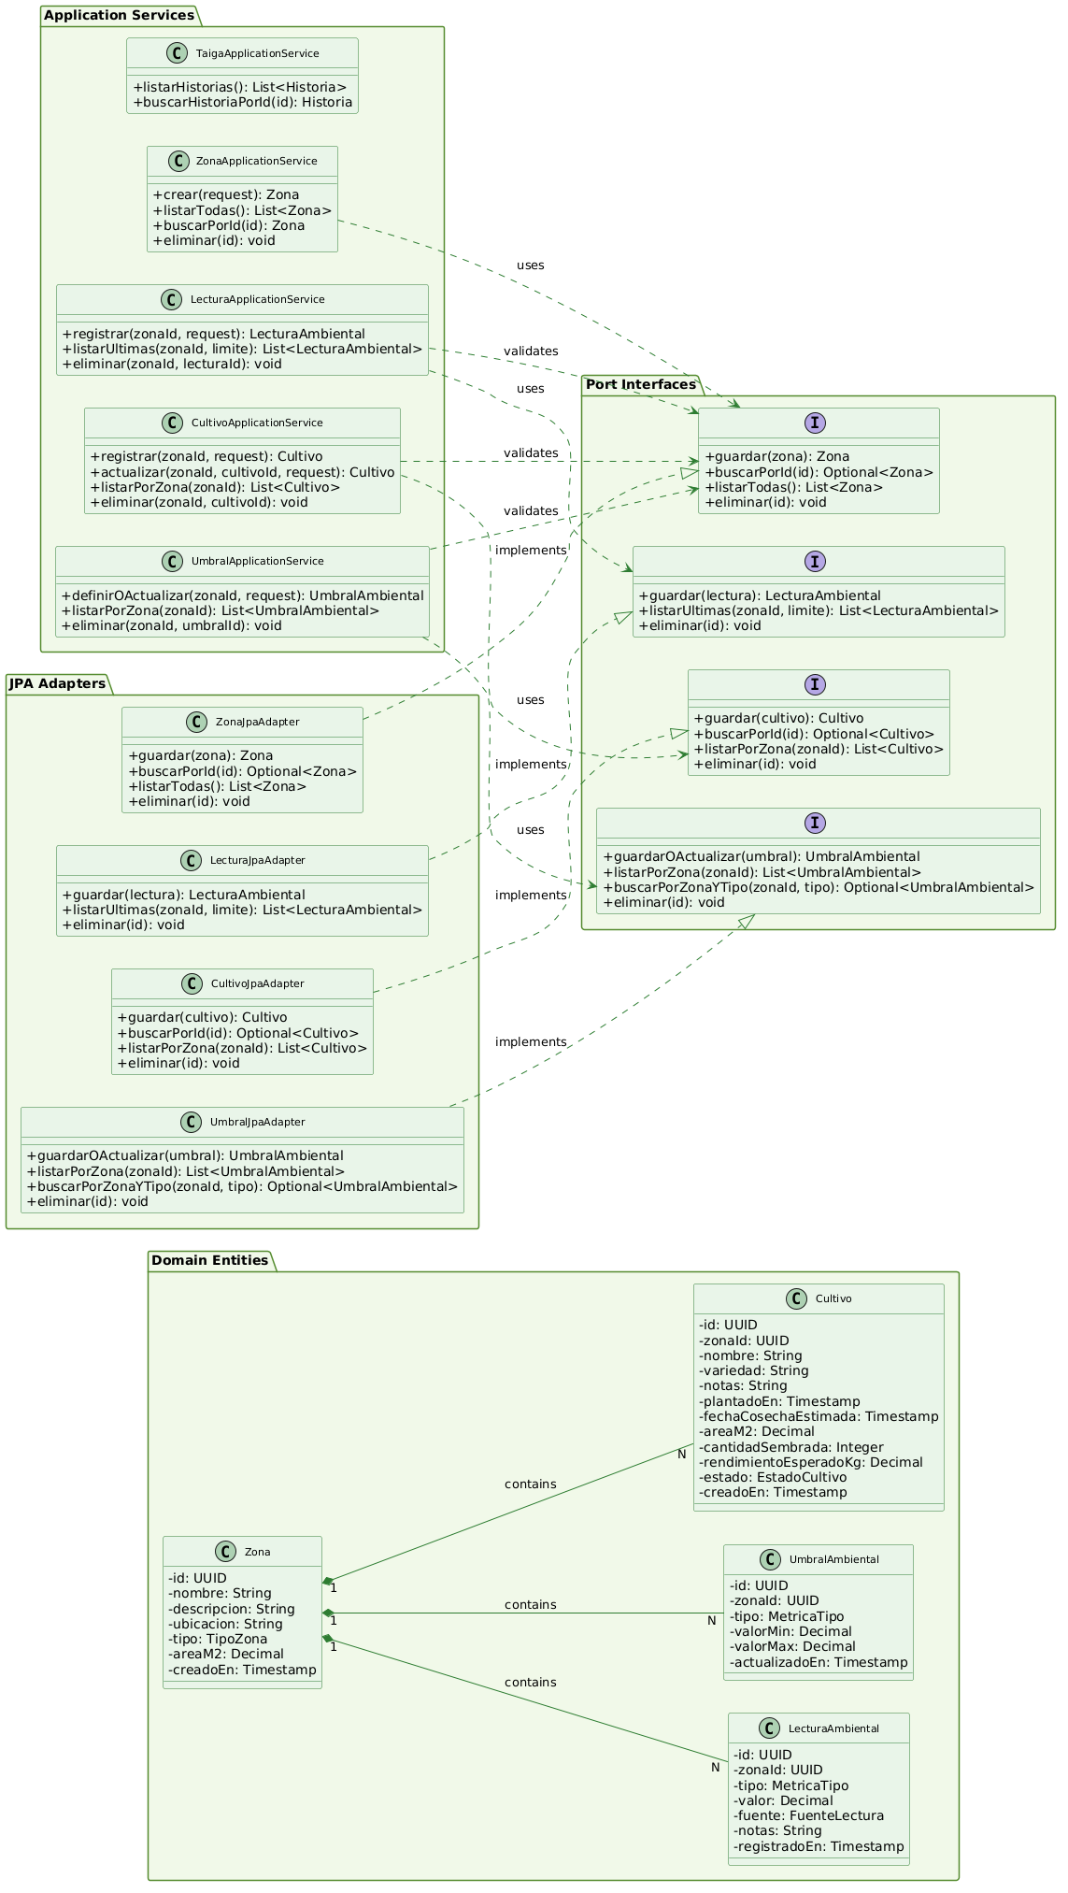



ENTITY-RELATIONSHIP DIAGRAM
The entity-relationship diagram of the Smart Greenhouse system reflects the relational model implemented in PostgreSQL. The diagram is built directly into the application as a dedicated module accessible from the main navigation panel, allowing any authenticated user to consult the database structure without leaving the platform.
The model is composed of four main entities: ZONA, CULTIVO, LECTURA_AMBIENTAL, and UMBRAL_AMBIENTAL. The ZONA entity acts as the central aggregation point of the model, maintaining three one-to-many (1:N) relationships with the remaining entities. This means that a single zone can contain multiple crops, multiple environmental readings, and multiple environmental thresholds, while each crop, reading, and threshold belongs to exactly one zone. All foreign key relationships are established through the zona_id field present in each dependent table.
The CULTIVO entity stores agronomic data for each planting registered within a zone, including fields such as variety, planting date, estimated harvest date, planted area, expected yield, and crop status. The estado field references the EstadoCultivo enumeration, which defines four possible values: ACTIVO, EN_PREPARACION, COSECHADO, and PERDIDO. The tipo field in the ZONA entity references the TipoZona enumeration, with values INVERNADERO, CAMPO_ABIERTO, HIDROPONICO, and MACETAS.
The LECTURA_AMBIENTAL entity records individual environmental measurements per zone, including the metric type, numeric value, data source, optional notes, and timestamp. The tipo field references the MetricaTipo enumeration with values TEMPERATURA_C, HUMEDAD_RELATIVA_PCT, LUZ_LUX, and HUMEDAD_SUELO_PCT. The fuente field references the FuenteLectura enumeration, which distinguishes between MANUAL and SENSOR_AUTOMATICO readings.
The UMBRAL_AMBIENTAL entity defines the acceptable operating range for a specific metric within a zone through minimum and maximum decimal values, along with a timestamp indicating the last modification. Like readings, the tipo field in this entity also references the MetricaTipo enumeration.
https://mi-invernadero-one.vercel.app/panel/diagrama
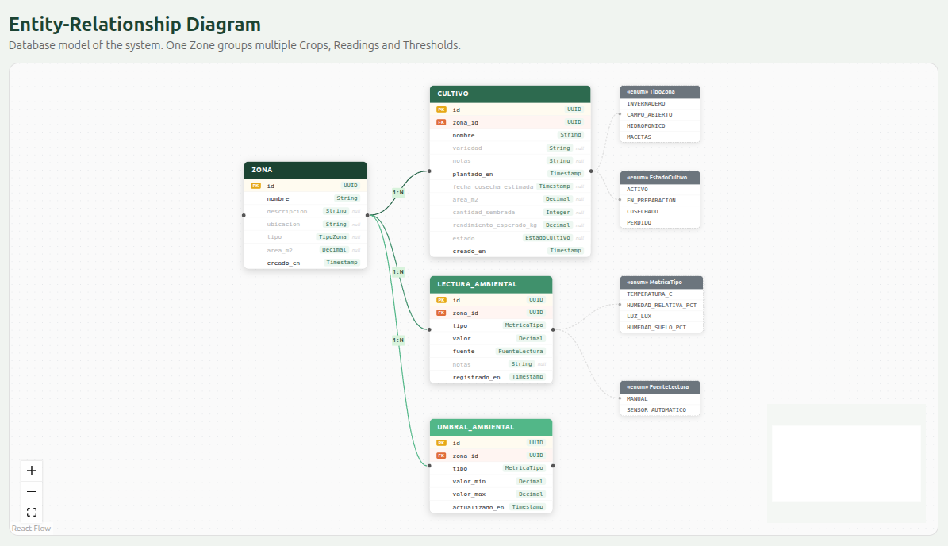

WEB SERVICE CATALOG AND API DOCUMENTATION
The backend of the Smart Greenhouse system is built using Spring Boot 3.5 and exposes a RESTful API organized into six functional groups: zone management, crop management, environmental readings, environmental thresholds, authentication, and Taiga integration. All endpoints follow REST conventions for HTTP methods and status codes, use JSON as the data exchange format, and require an active OAuth2 session to be accessed. Requests made without a valid session are rejected with an HTTP 401 Unauthorized response. The complete API documentation, including interactive request examples and response schemas, is automatically generated from code annotations using SpringDoc OpenAPI and is available at https://invernadero-back.onrender.com/swagger-ui/index.html.

11.1 ZONE MANAGEMENT
The zone endpoints allow authenticated users to create, list, and delete greenhouse zones. All zone identifiers are UUIDs generated automatically by the backend upon creation.
Method | Endpoint | Description | Request Body | Response
GET | /api/v1/zonas | List all registered zones | — | 200 → ZonaResponse[]
POST | /api/v1/zonas | Create a new zone | CrearZonaRequest | 201 → ZonaResponse
DELETE | /api/v1/zonas/{zonaId} | Delete a zone and all its associated data | — | 204
CrearZonaRequest:
json
{
"nombre": "North Zone",
"descripcion": "Main leafy crop zone",
"ubicacion": "Block A, greenhouse 1",
"tipo": "INVERNADERO | CAMPO_ABIERTO | HIDROPONICO | MACETAS",
"areaM2": 120.50

}

11.2 CROP MANAGEMENT
The crop endpoints are scoped to a specific zone through the zonaId path parameter. All crop operations first verify the existence of the parent zone before executing.
Method | Endpoint | Description | Request Body | Response
GET | /api/v1/zonas/{zonaId}/cultivos | List all crops in a zone | — | 200 → CultivoResponse[]
POST | /api/v1/zonas/{zonaId}/cultivos | Register a new crop in a zone | CrearCultivoRequest | 201 → CultivoResponse
PUT | /api/v1/zonas/{zonaId}/cultivos/{cultivoId} | Update an existing crop | ActualizarCultivoRequest | 200 → CultivoResponse
DELETE | /api/v1/zonas/{zonaId}/cultivos/{cultivoId} | Delete a crop | — | 204
CrearCultivoRequest:
json
{
"nombre": "Lettuce",
"variedad": "Batavia",
"notas": "First planting of the season",
"plantadoEn": "2026-04-15T08:00:00Z",
"fechaCosechaEstimada": "2026-06-15T08:00:00Z",
"areaM2": 20.00,
"cantidadSembrada": 200,
"rendimientoEsperadoKg": 150.00,
"estado": "ACTIVO | EN_PREPARACION | COSECHADO | PERDIDO"
}

11.3 ENVIRONMENTAL READINGS
The readings endpoints allow users to register and consult environmental measurements per zone. The listing endpoint accepts an optional limite query parameter that defaults to 50 records.
Method | Endpoint | Description | Request Body | Response
GET | /api/v1/zonas/{zonaId}/lecturas?limite=50 | Get the last N readings for a zone | — | 200 → LecturaResponse[]
POST | /api/v1/zonas/{zonaId}/lecturas | Register a new environmental reading | RegistrarLecturaRequest | 201 → LecturaResponse
DELETE | /api/v1/zonas/{zonaId}/lecturas/{lecturaId} | Delete a reading | — | 204
RegistrarLecturaRequest:
json
{
"tipo": "TEMPERATURA_C | HUMEDAD_RELATIVA_PCT | LUZ_LUX | HUMEDAD_SUELO_PCT",
"valor": 22.5,
"fuente": "MANUAL | SENSOR_AUTOMATICO",
"notas": "Measured at 8:00 AM before irrigation"
}

11.4 ENVIRONMENTAL THRESHOLDS
The threshold endpoints implement an upsert pattern: if a threshold already exists for the given metric type and zone, it is updated rather than duplicated. This ensures that only one threshold per metric type exists per zone at any given time.
Method | Endpoint | Description | Request Body | Response
GET | /api/v1/zonas/{zonaId}/umbrales | List all thresholds for a zone | — | 200 → UmbralResponse[]
PUT | /api/v1/zonas/{zonaId}/umbrales | Create or update a threshold (upsert) | DefinirUmbralRequest | 200 → UmbralResponse
DELETE | /api/v1/zonas/{zonaId}/umbrales/{umbralId} | Delete a threshold | — | 204
DefinirUmbralRequest:
json
{
"tipo": "TEMPERATURA_C | HUMEDAD_RELATIVA_PCT | LUZ_LUX | HUMEDAD_SUELO_PCT",
"valorMin": 15.00,
"valorMax": 35.00
}

11.5 AUTHENTICATION
The authentication endpoints manage the OAuth2 session lifecycle. The sign-in flow is initiated by redirecting the browser to the Google authorization endpoint, while session status and sign-out are handled through dedicated API endpoints.
Method | Endpoint | Description
GET | /api/v1/auth/status | Returns the current session status (authenticated, email, oauth2Enabled)
POST | /api/v1/auth/logout | Invalidates the current session and clears the session cookie
GET | /oauth2/authorization/google | Initiates the OAuth2 Authorization Code Flow with Google

11.6 TAIGA INTEGRATION (PROXY)
The Taiga endpoints act as a server-side proxy toward the external Taiga.io REST API. This design keeps the Taiga bearer token on the backend, preventing its exposure to the browser and ensuring secure communication with the external platform.
Method | Endpoint | Description
GET | /api/v1/taiga/historias | Returns the complete list of user stories from the configured Taiga project
GET | /api/v1/taiga/historias/{id} | Returns a specific user story by its internal Taiga ID

11.7 ERROR HANDLING
All error responses follow the RFC 9457 Problem Details standard, providing a consistent and structured error format across all endpoints. The following JSON structure is returned for any error condition:
json
{
"type": "about:blank",
"title": "Not Found",
"status": 404,
"detail": "Zone with id 123e4567-e89b-12d3-a456-426614174000 not found",
"instance": "/api/v1/zonas/123e4567-e89b-12d3-a456-426614174000"
}
The most common HTTP status codes returned by the API are the following: 400 Bad Request is returned when field validation fails, such as submitting a zone without a name; 401 Unauthorized is returned for any request made without an active OAuth2 session; 404 Not Found is returned when the requested resource does not exist in the database; and 500 Internal Server Error is returned for unexpected failures on the server side.

TESTING
The validation process of the Smart Greenhouse system was carried out progressively, covering each technological layer independently before integrating them into a complete end-to-end verification. The testing strategy was designed to reflect the hexagonal architecture of the backend, where the business logic can be tested in isolation from infrastructure dependencies, as well as the full communication flow between the React frontend and the Spring Boot backend. The test suite is organized into four categories: unit tests using JUnit 5 and Mockito, integration tests using MockMvc, REST API tests using Python and pytest, and end-to-end interface tests using Selenium and Python.
All tests are executed automatically as part of the CI/CD pipeline configured in GitHub Actions. On every push to the main branch, the pipeline runs the backend test suite before authorizing deployment to Render, ensuring that no broken code reaches the production environment. This automation guarantees a minimum level of quality control on every code change delivered by the development team.

12.1 UNIT TESTS — JUNIT 5 + MOCKITO
Unit tests focus on the application service classes of the backend, verifying that business logic behaves correctly in isolation from the database and HTTP layers. All dependencies are replaced by Mockito mocks, allowing tests to run without a running database or external services. A total of 14 unit and integration tests were implemented across four test classes.
ZonaApplicationServiceTest — 6 tests:
Test | Description
crear_debePersistirYRetornarZona | Verifies that the service calls zonaPort.guardar() with the correct data and returns the persisted zone
buscarPorId_debeRetornarZonaSiExiste | Verifies that the service returns the correct zone when it exists in the repository
buscarPorId_debeLanzarExcepcionSiNoExiste | Verifies that a RecursoNoEncontradoException is thrown when the zone does not exist
listarTodas_debeRetornarListaCompleta | Verifies that the service correctly delegates the listing operation to the persistence port
eliminar_debeBorrarZonaYDatosDependientes | Verifies that cascade deletion removes all associated readings, crops, and thresholds before deleting the zone
eliminar_debeLanzarExcepcionSiZonaNoExiste | Verifies that no deletion is performed when the specified zone does not exist
ZonaControllerTest — 5 tests (MockMvc, HTTP layer):
Test | HTTP | Description
listar_debeRetornarListaConStatus200 | GET /api/v1/zonas | Verifies HTTP 200 response and JSON content type
crear_debeRetornarZonaCreada | POST /api/v1/zonas | Verifies HTTP 201 response with the created zone body
crear_conNombreVacio_debeRetornar400 | POST /api/v1/zonas | Verifies that field validation returns HTTP 400
eliminar_debeRetornar204 | DELETE /api/v1/zonas/{id} | Verifies HTTP 204 response for successful deletion
eliminar_zonaInexistente_debeRetornar404 | DELETE /api/v1/zonas/{id} | Verifies HTTP 404 response when the zone does not exist

AuthControllerTest — 2 tests:
Test | Description
status_sinSesion_retornaNoAutenticado | Verifies the response structure when no active session exists
logout_retorna200 | Verifies that the logout endpoint responds correctly

InvernaderoApiApplicationTests — 1 test:
Test | Description
contextLoads | Verifies that the Spring application context starts correctly with the test configuration
Total JUnit: 14 tests, 0 failures.

12.2 REST API TESTS — PYTHON + PYTEST
REST API tests verify the behavior of the backend endpoints from an external client perspective, simulating the same HTTP requests that the frontend would send. These tests require the backend running locally at localhost:8081 with the APP_OAUTH2_ENABLED=false flag, which disables OAuth2 authentication to allow unauthenticated test requests.
test_zonas.py — 6 tests:
Test | Description
test_listar_zonas_retorna_200 | Verifies that GET /api/v1/zonas returns HTTP 200
test_crear_zona_retorna_201 | Verifies that POST /api/v1/zonas returns HTTP 201 with the created zone
test_crear_zona_sin_nombre_retorna_400 | Verifies that submitting a zone without a name returns HTTP 400
test_zona_aparece_en_listado | Verifies that a newly created zone appears in the listing response
test_eliminar_zona_retorna_204 | Verifies that DELETE /api/v1/zonas/{id} returns HTTP 204
test_zona_eliminada_no_aparece | Verifies that a deleted zone no longer appears in the listing
test_cultivos.py — 6 tests:

Test | Description
test_listar_cultivos_retorna_200 | Verifies that GET /api/v1/zonas/{zonaId}/cultivos returns HTTP 200
test_crear_cultivo_retorna_201 | Verifies that POST /api/v1/zonas/{zonaId}/cultivos returns HTTP 201
test_crear_cultivo_sin_nombre_retorna_400 | Verifies that submitting a crop without a name returns HTTP 400
test_cultivo_aparece_en_listado | Verifies that a newly created crop appears in the zone's crop list
test_actualizar_cultivo_retorna_200 | Verifies that PUT /api/v1/zonas/{zonaId}/cultivos/{id} returns HTTP 200
test_eliminar_cultivo_retorna_204 | Verifies that DELETE /api/v1/zonas/{zonaId}/cultivos/{id} returns HTTP 204
test_lecturas.py and test_umbrales.py cover registration, listing, and deletion of environmental readings and thresholds respectively, following the same structure as the zone and crop tests.
To execute the full REST API test suite:
bash
cd invernadero-tests
pip install pytest requests
pytest api/ -v
Total Python API tests: 20+ tests, 0 failures.

12.3 END-TO-END TESTS — SELENIUM + PYTHON
End-to-end tests validate the complete user interface behavior by automating browser interactions through Selenium 4 with Chrome in headless mode. These tests require both the frontend running at localhost:5173 and the backend running at localhost:8081. The Chrome driver is configured with --headless=new flag and a resolution of 1280x900 pixels.
Test | Description
test_titulo_zonas_visible | Verifies that the zones page displays an H2 heading containing "Zone"
test_crear_zona | Simulates the complete flow: click the create button, fill the form, save, and verify the zone appears in the table
test_titulo_lecturas_visible | Verifies that the readings page heading is correctly displayed
test_registrar_lectura | Selects a zone, enters value 22.5, and verifies the reading appears in the table
test_titulo_cultivos_visible | Verifies that the crops page heading is correctly displayed
test_crear_cultivo | Creates a crop named "Tomate Selenium" and verifies it appears in the table
test_titulo_umbrales_visible | Verifies that the thresholds page heading is correctly displayed
test_definir_umbral | Defines a threshold with minimum 10 and maximum 40 and verifies it appears in the table
test_navegacion_sidebar | Navigates through Readings → Crops → Thresholds verifying the correct URLs

To execute the end-to-end test suite:
bash
cd invernadero-tests
pip install pytest selenium webdriver-manager
pytest ui_tests/ -v
Total Selenium tests: 9 tests, 0 failures.

12.4 AUTOMATED DOCUMENTATION GENERATION — JAVADOC
Beyond code testing, the project automates technical documentation generation using the maven-javadoc-plugin configured in pom.xml. This plugin reads the Javadoc comments (/** */) written in every public class and method across the source code and generates a complete HTML documentation site without any manual intervention.
The generar-docs.sh script at the project root encapsulates this automation:
#!/bin/bash
# Reads all Java source files and generates HTML documentation
cd invernadero-back && ./mvnw javadoc:javadoc --quiet
# Output: invernadero-back/target/site/apidocs/index.html
Running ./generar-docs.sh from the project root produces the full Javadoc HTML site. The documentation is also available through the OpenAPI/Swagger UI generated automatically by the springdoc-openapi-starter-webmvc-ui dependency declared in pom.xml, which scans all @RestController classes and publishes interactive API documentation at /swagger-ui/index.html.

12.4 TEST SUMMARY
The following table summarizes the complete test coverage achieved across all layers of the system:
Category | Tool | Tests | Result
Unit tests | JUnit 5 + Mockito | 6 | ✅ All passed
Integration tests (HTTP) | MockMvc | 7 | ✅ All passed
REST API tests | Python + pytest | 20+ | ✅ All passed
End-to-end tests | Selenium + Python | 9 | ✅ All passed

GRAPHICAL MODEL OF THE PROPOSED SYSTEM
The Smart Greenhouse system is based on a three-tier cloud architecture that integrates a React frontend, a Spring Boot backend, and a PostgreSQL relational database, complemented by an external connection to the Taiga.io project management platform. The proposed model describes the complete data flow from user interaction in the browser to data persistence in the cloud database, coherently integrating the OAuth2 authentication mechanism, the REST API communication layer, and the CI/CD automation pipeline that governs the deployment lifecycle of the system.

13.1 SYSTEM ARCHITECTURE
The architecture is organized into four main levels: the user interface layer, the backend services layer, the database layer, and the external integrations layer.
At the first level, the user interacts with the web application through a browser, accessing the frontend deployed on Vercel's global CDN. The frontend is a Single Page Application built with React 19 and TypeScript, organized into nine main routes: /login, /panel/zonas, /panel/cultivos, /panel/lecturas, /panel/umbrales, /panel/taiga, /panel/diagrama, and /panel/perfil. All routes except /login are protected and require an active OAuth2 session. HTTP communication with the backend is handled exclusively through Axios with the withCredentials flag enabled, which ensures that the session cookie is included in every cross-domain request between Vercel and Render.
At the second level, the Spring Boot 3.5 backend deployed on Render receives all API requests and manages the complete business logic through its hexagonal architecture. The backend is organized into controllers that handle HTTP routing, application services that encapsulate business rules, port interfaces that define persistence contracts, and JPA adapters that implement those contracts using Spring Data and Hibernate. The Spring Security module intercepts every incoming request and validates the session before forwarding it to the corresponding controller. Cross-origin requests from the Vercel frontend are explicitly allowed through CORS configuration, and session cookies are configured with HttpOnly, Secure, and SameSite=None flags to ensure correct transmission across different domains.
At the third level, the PostgreSQL 15 managed database hosted on Render stores all persistent data across the four main tables: zonas, cultivos, lecturas_ambientales, and umbrales_ambientales. The backend communicates with the database through JDBC using Hibernate as the ORM layer. On startup with an empty database, the SampleDataLoader component automatically inserts three zones, five crops, ten readings, and six thresholds as demonstration data, ensuring the application is immediately presentable without manual intervention.
At the fourth level, the Taiga.io external platform is consulted by the backend through its REST API using a bearer token stored as a server-side environment variable. This proxy design ensures that the authentication token is never exposed to the browser, following security best practices for third-party API integrations.

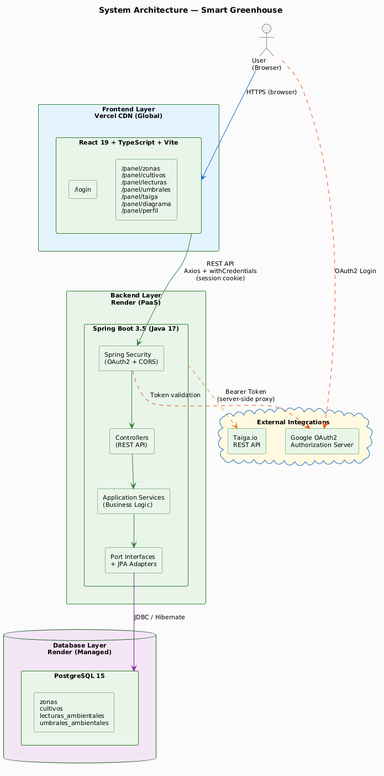

13.2 CI/CD Pipeline
The continuous integration and continuous deployment pipeline is configured using GitHub Actions and defined in the ci.yml file located at the root of the repository. The pipeline is triggered automatically on every push to the main branch and on pull requests. The ci.yml file includes detailed inline comments explaining each step, flag, and environment variable, making the automation process fully transparent and maintainable. Additionally, the project includes a dedicated shell script, generar-docs.sh, located at the project root, which automates Javadoc HTML documentation generation by reading all Java source files and producing an HTML report at invernadero-back/target/site/apidocs/index.html.
The first job, test-backend, compiles the Java backend and executes the full JUnit test suite. If any test fails, the pipeline is interrupted and no deployment is performed. The second job, build-frontend, runs in parallel with the backend tests and executes the TypeScript compiler (tsc) followed by the Vite production build. This job ensures that the frontend has no type errors and produces a valid build artifact before deployment. Both jobs must pass successfully for the third job to be triggered.
The third job, deploy, sends a webhook request to Render using a configured secret URL (stored as RENDER_DEPLOY_HOOK_URL in GitHub Secrets), which instructs the Render platform to pull the latest code from the repository and redeploy the backend service automatically. This job only runs after both test-backend and build-frontend complete successfully, and only on direct pushes to main — not on pull requests. The entire ci.yml file is fully commented, documenting the purpose of each step, flag, and environment variable for maintainability.
This pipeline design guarantees that only code that passes all automated tests reaches the production environment, reducing the risk of regressions and ensuring a reliable and consistent deployment process for every change delivered by the development team.
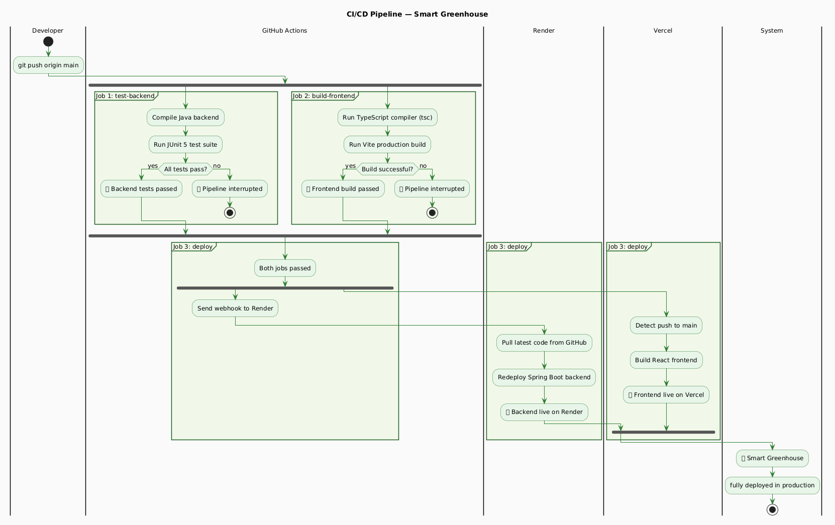

RESULTS AND CONCLUSION
The development and implementation of the Smart Greenhouse system enabled a comprehensive evaluation of the full-stack architecture, the automated testing strategy, and the continuous deployment pipeline configured for the project. The results obtained reflect stable and consistent behavior across all layers of the system, achieving a fully operational web application for environmental monitoring and crop management in agricultural greenhouses.

14.1 RESULTS
The following table summarizes the completion status of each item evaluated in the project rubric, along with the corresponding evidence:
Rubric Item | Status | Evidence
JSON Model / Database / ER Diagram / Data Dictionary | ✅ Complete | 4 tables in PostgreSQL, data dictionary in attached spreadsheet, ER diagram integrated as application module
Spring Boot backend based on JSON model | ✅ Complete | 6 controllers, 4 application services, hexagonal architecture, 59 Java files
React frontend based on JSON model | ✅ Complete | 9 React + TypeScript pages, typed interfaces with 1:1 correspondence to the API
Frontend tests (Selenium) | ✅ Complete | 9 end-to-end tests in Python covering all main UI flows
Backend tests (JUnit) | ✅ Complete | 14 tests: unit tests with Mockito + integration tests with MockMvc
Python tests (REST API) | ✅ Complete | 20+ API tests with pytest + requests
GitHub Actions CI/CD deployment | ✅ Complete | Pipeline with 3 jobs: test-backend, build-frontend, deploy to Render
OAuth2 / Gmail Security / Spring Security | ✅ Complete | OAuth2 Authorization Code Flow with Google, SameSite=None cookies, CORS configured
Backend and frontend internationalization | ✅ Complete | ES + EN in all interface texts, preference persisted in localStorage
Automatic Swagger UI at /swagger-ui/index.html; Javadoc on all public classes; file headers in every source file; generar-docs.sh script for one-command HTML documentation generation. | ✅ Complete | Automatic Swagger UI, Javadoc on all public classes, headers in every source file
Taiga connectivity — user stories | ✅ Complete | Table with reference, title, assignee, and real-time status from Taiga API

14.2 CONCLUSION
The development of the Smart Greenhouse system validated the technical feasibility of building a complete full-stack web application for agricultural greenhouse management using modern and well-documented technologies. The results obtained across all project dimensions — architecture, testing, security, internationalization, and deployment — confirm that the stated objectives were fully achieved.
Regarding the backend architecture, the hexagonal pattern proved to be one of the most valuable decisions of the project. The separation between business logic and infrastructure details allowed the application service classes to be tested in complete isolation using Mockito mocks, without requiring a running database or any external service. This significantly accelerated the unit testing cycle and made the codebase more maintainable and extensible for future changes.
The most significant technical challenge encountered during development was the configuration of cross-domain OAuth2 sessions between the Vercel frontend and the Render backend. Since both services operate on different domains, the browser's default cookie policies blocked the session cookie from being transmitted in cross-origin requests. This was resolved through a combination of Spring Security configuration, the SameSite=None; Secure cookie flags, the forward-headers-strategy: framework setting, and explicit CORS configuration allowing credentials from the Vercel origin. This experience provided a deep practical understanding of browser security policies and their implications for modern distributed web architectures.
The CI/CD pipeline configured with GitHub Actions proved to be an essential component of the development workflow. By automatically running the full test suite on every push to the main branch and blocking deployment when any test fails, the pipeline ensured that the production environment always reflected a verified and stable version of the application. This automation reduced manual intervention in the deployment process and reinforced the culture of continuous quality assurance within the development team.
The integration with Taiga.io through a server-side proxy demonstrated a good security practice for third-party API integrations that require authentication: the bearer token is stored as a Render environment variable and never transmitted to the client. The use of a non-expiring Application Token (configured in Taiga Settings → Apps) eliminated the operational burden of rotating tokens periodically, which had caused disconnections during development.
The automatic loading of demonstration data through the SampleDataLoader component proved to be a practical decision for academic presentations, populating the database with realistic data on every clean startup. Similarly, the generar-docs.sh automation script demonstrated the value of encapsulating documentation generation in a single executable command, allowing the Javadoc HTML site to be regenerated at any time from the source code annotations without manual steps.
Overall, the Smart Greenhouse project provides a solid and well-documented foundation for future extensions, including real IoT sensor integration, alert notification systems based on threshold violations, statistical dashboards for environmental trend analysis, and role-based access control for multi-user environments.

BIBLIOGRAPHY
- Beck, K. (2002). Test-driven development: By example. Addison-Wesley Professional.
- Cockburn, A. (2005). Hexagonal architecture. Retrieved from https://alistair.cockburn.us/hexagonal-architecture/
- Evans, E. (2003). Domain-driven design: Tackling complexity in the heart of software. Addison-Wesley Professional.
- Fielding, R. T. (2000). Architectural styles and the design of network-based software architectures (Doctoral dissertation). University of California, Irvine. https://www.ics.uci.edu/~fielding/pubs/dissertation/top.htm
- Fowler, M. (2002). Patterns of enterprise application architecture. Addison-Wesley Professional.
- GitHub. (2024). GitHub Actions documentation. Retrieved from https://docs.github.com/en/actions
- Google. (2024). Google Identity: OAuth 2.0 for web server applications. Retrieved from https://developers.google.com/identity/protocols/oauth2/web-server
- Internet Engineering Task Force. (2023). RFC 9457: Problem details for HTTP APIs. Retrieved from https://www.rfc-editor.org/rfc/rfc9457
- Pivotal Software. (2024). Spring Boot reference documentation (3.5). Retrieved from https://docs.spring.io/spring-boot/docs/3.5.x/reference/html/
- Pivotal Software. (2024). Spring Security reference documentation. Retrieved from https://docs.spring.io/spring-security/reference/
- Render. (2024). Render documentation: Deploy a web service. Retrieved from https://render.com/docs/web-services
- Taiga. (2024). Taiga REST API documentation. Retrieved from https://docs.taiga.io/api.html
- Vercel. (2024). Vercel documentation: Deploying React applications. Retrieved from https://vercel.com/docs/frameworks/react
- Walls, C. (2022). Spring in action (6th ed.). Manning Publications.
- Wieruch, R. (2023). The road to React. Self-published. Retrieved from https://www.roadtoreact.com

